|  |
| --- |
| **LOAN APPROVAL PREDICTION**  An Industry Oriented Project (IOP) Report Submitted  In partial fulfillment of the requirement for the award of the degree of  **Bachelor of Technology in**  **Computer Science and Engineering (Data Science)**  **by**  **VENNA NANDA JAYA KRISHNA 22N31A67J1**  **POSHETTY SAITEJA 22N31A67D7**  **MOHD ALI 22N35A6715**  Under the guidance of  **Dr. I Nagaraju**  Professor  **Department of Emerging Technologies**  MRCET (Autonomous Institution, UGC Govt. of India)    MRCET CAMPUS  **DEPARTMENT OF COMPUTER SCIENCE AND ENGINEERING**  **(EMERGING TECHNOLOGIES)**  **MALLA REDDY COLLEGE OF ENGINEERING AND TECHNOLOGY**  **(Autonomous Institution – UGC, Govt. of India)**  **(Affiliated to JNTU, Hyderabad, Approved by AICTE, Accredited by NBA & NAAC – ‘A’ Grade, ISO 9001:2015 Certified)** Maisammaguda(v), Near Dullapally, Via: Kompally, Hyderabad – 500 100, Telangana State, India  **2023-2024** |

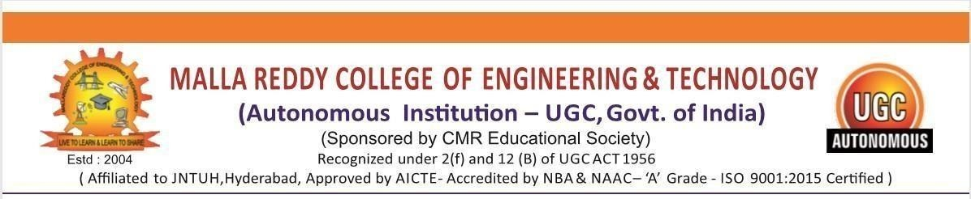

**CERTIFICATE**

This is to certify that this is the Bonafide record of the project titled “**Loan Approval**

**Prediction**”, submitted by **VENNA NANDA JAYA KRISHNA** (22N31A67J1**) SAITEJA (**22N31A67D7) and **MOHD ALI (**23N35A6715) of **B.Tech II YEAR – II** Semester in the partial fulfillment of the requirements for the degree of Bachelor of Technology in **Computer Science and Engineering (Data Science)**, Dept. of CSE (Emerging Technologies) during the year 2023-2024. The results embodied in this project report have not been submitted to any other university or institute for the award of any degree or diploma.

|  |  |
| --- | --- |
| **Dr. M V Kamal**  Head Of the Department (ET) **Department of CSE (ET)** | **Dr. P Dileep**  Project Coordinator  **Department of CSE (ET)** |
| **EXTERNAL EXAMINER** | **Dr. I Nagaraju**  **Professor**  **Department Of CSE (ET)** |

# DECLARATION

We hereby declare that the project entitled “**Loan Approval Prediction**” submitted to

**Malla Reddy College of Engineering and Technology,** affiliated to Jawaharlal Nehru Technological University Hyderabad (JNTUH) as part of **III Year B.Tech – I** Semester and for the partial fulfillment of the requirement for the award of **Bachelor of Technology** in **Computer Science and Engineering (Data Science)** is a result of original research work done by me.

It is further declared that the project report or any part thereof has not been previously submitted to any University or Institute for

**VENNA NANDA JAYA KRISHNA** (22N31A67J1)

**POSHETTY SAITEJA** (22N31A67D7)

**MOHD ALI** (22N35A6715)

## ACKNOWLEDGEMENTS

We feel ourself honored and privileged to place our warm salutation to our college “Malla Reddy College of Engineering and Technology (Autonomous Institution – UGC Govt. of India) and our Principal **Dr. S Srinivasa Rao,** Professor who gave us the opportunity to do the Application Development -1 (Project) during our III Year B.Tech – I Semester and profound the technical skills.

We express our heartiest thanks to our Director **Dr. VSK Reddy,**Professor for encouraging us in every aspect of our project and helping us realize our full potential.

We also thankful to our Head of the Department **Dr. M V Kamal,** Professor for providing training and guidance, excellent infrastructure and a nice atmosphere for completing this project successfully.

We would like to express our sincere gratitude and indebtedness to our project supervisor **Dr. P DILEEP,** Project Coordinator for his valuable suggestions and interest throughout the course of this project.

We convey our heartfelt thanks to our Project Coordinator **Dr. I NAGARAJU,** Professor for allowing for their regular guidance and constant encouragement during our dissertation work.

We would like to thank all our supporting **staff** of the Department of CSE(Emerging Technologies) and even all other department who have been helpful directly and in-directly in making our project a success.

Finally, we would like to take this opportunity to thank our **families** for their support and blessings for completion of our project that gave us the strength to do our project.

**VENNA NANDA JAYA KRISHNA** (22N31A67J1)

**POSHETTY SAITEJA** (22N31A67D7)

**MOHD ALI** (22N35A6715)

**TABLE OF CONTENTS**

|  |  |  |  |
| --- | --- | --- | --- |
| **Chapter No.** | | **Contents** | **Page no** |
| 1 | 1.1 | Introduction | 1 |
|  | 1.2 | Motivation | 3 |
|  | 1.3 | Problem definition | 5 |
|  | 1.4 | Objective of project | 5 |
| 2 | 2.1 | Existing system & Proposed system | 6 |
|  | 2.2 | Functional Requirements | 8 |
| 3 | 3.1 | Software Environment | 10 |
| 4 | 4.1 | System Design & UML Diagrams | 11 |
| 5 | 5.1 | Software development life cycle | 15 |
| 6 | 6.1 | Implementation | 17 |
| 7 | 7.1 | Testing | 19 |
| 8 | 8.1 | Output screen | 20 |
|  |  |  | 21-23 |
| 9 | 9.1 | Conclusion,Future scope & Reference |  |

i

## ABSTRACT

In today's dynamic financial landscape, the efficient and accurate assessment of loan applications is crucial for financial institutions to maintain a healthy lending portfolio. This study explores the application of machine learning techniques to predict loan approval outcomes based on historical data. Leveraging a diverse set of featuresencompassing applicant demographics, financial history, and economicindicators, our predictive model aims to enhance the decision-making process in loan approval.

The dataset utilized in this research spans a comprehensive range of parameters, including credit scores, income levels, employment history, and other relevant variables. Various machine learning algorithms, such as logistic regression, decision trees, and ensemble methods, are employed to analyze the dataset and identify patterns that contribute to successful loan approvals. Feature engineering techniquesare applied to optimize the model's performance and interpretability.

Through a rigorous evaluation process involving cross-validation and performance metrics such as precision, recall, and F1 score, the proposed machine learning model demonstrates its efficacy in predicting loan approval outcomes. The study also explores interpretability tools to provide insights into the factors influencing the model's decisions, promoting transparency and trust in the predictive process.

Furthermore, the research discusses the implications of integrating such predictive models into the existing loan approval workflow of financialinstitutions. Potential benefits include reduced processing time, improved risk management, and enhanced objectivity in decision-making. Ethical considerations, fairness, and bias mitigation strategiesare also addressed to ensure responsible and equitable lending practices.

Ultimately, this study contributes to the growing body of knowledgein the field of financial technology, demonstrating the potential of machine learning to optimize loan approval processes and foster a more data-driven and efficient financial ecosystem

**CHAPTER 1 INTRODUCTION**

### 1.1 INTRODUCTION

Loans are the major requirement of the modern world. By this only, Banks get a major part of the total profit. It is beneficial for students to manage their education and living expenses, and for people to buy any kind of luxury like houses, cars, etc.

But when it comes to deciding whether the applicant’s profile is relevant to be granted with loan or not. Banks have to look after many aspects. So,here we will be using Machine Learning with Python to ease their work and predict whether the candidate’s profile is relevant or not using key features like Marital Status, Education, Applicant Income, Credit History, etc. However, the traditional methods for evaluating the creditworthiness of loan applicants have often been fraught with challenges such as subjectivity, time-consuming manual assessments, and the potential for human bias.

This project, titled "Loan Prediction Using Machine Learning," is a timely exploration ofthe intersection between finance and artificial intelligence. It delves into the application of machine learning algorithms to streamline the loan approval process, enhance its accuracy, and reduce the associated

Risks.We also offer a glimpse into the goals and objectives of this project, emphasizing the potential for machine learning to transform the landscape of lending and borrowing, paving the way for a more robust, efficient, and just financial system.

The Loan Approval System is designed to cater to financial institutions,lending agencies, and credit unions seeking to modernize their loan approval processes. It is intended for use by loan officers, risk analysts,and other stakeholders involved in the lending and borrowers.

Using information provided by the application, machine learning algorithms can predict whether or not a loan will be accepted. This is a type of classification problem. The applicant's

**1.2 MOTIVATION**

The motivation behind our project, the loan approval system using machine learning, is to revolutionize the traditional loan approval process. By incorporating machine learning algorithms, we aim to enhance the efficiency, accuracy, and speed of loan approvals.

One key motivation is to minimize human bias in the decision-making process. Machine learning models can analyze vast amounts of data and identify patterns that humans might overlook. This can lead to fairer and more objective loan approvals, ensuring equal opportunitiesfor everyone.

Another motivation is to reduce the time and effort required for loan approval. Traditional methods often involve manual document verification and lengthy processing times. With machine learning, we can automate various aspects of the process, such as credit scoring and risk assessment, resulting in faster approvals and improved customer satisfaction. Additionally, implementing machine learning in the loan approval system can help mitigate risks. By analyzing historical data and real-time information, the models can identify potential fraud or default risks more accurately. This proactive approach can save financial institutions from potential losses and protect the interests of both lenders and borrowers.

**1.2 MOTIVATION**

The motivation behind our project, the loan approval system using machine learning, is to revolutionize the traditional loan approval process. By incorporating machine learning algorithms, we aim to enhance the efficiency, accuracy, and speed of loan approvals.

One key motivation is to minimize human bias in the decision-making process. Machine learning models can analyze vast amounts of data and identify patterns that humans might overlook. This can lead to fairer and more objective loan approvals, ensuring equal opportunitiesfor everyone.

Another motivation is to reduce the time and effort required for loan approval. Traditional methods often involve manual document verification and lengthy processing times. With machine learning, we can automate various aspects of the process, such as credit scoring and risk assessment, resulting in faster approvals and improved customer satisfaction. Additionally, implementing machine learning in the loan approval system can help mitigate risks. By analyzing historical data and real-time information, the models can identify potential fraud or default risks more accurately. This proactive approach can save financial institutions from potential losses and protect the interests of both lenders and borrowers.

One key motivation is to minimize human bias in the decision-making process. Machine learning models can analyze vast amounts of data and identify patterns that humans might overlook. This can lead to fairer and more objective loan approvals, ensuring equal opportunitiesfor everyone.With machine learning, we can automate various aspects of the process, such as credit scoring and risk assessment, resulting in faster approvals and improved customer satisfaction. Additionally, implementing machine learning in the loan approval system can help mitigate risks. By analyzing historical data and real-time information, the models can identify potential fraud or default risks more accurately. This proactive approach can save financial institutions from potential losses and protect the interests of both lenders and borrowers.

**1.3 PROBLEM DEFINITION:**

The problem definition for our loan approval system using machine learning. The traditional loan approval process can be time- consuming and prone to human bias. Manual document verification and subjective decision-making can lead to delays and inconsistenciesin loan approvals. This can be frustrating for borrowers and can also result in missed opportunities for lenders.

Moreover, the risk assessment process in traditional loan approval methods may not be as accurate as desired. It can be challenging to analyze vast amounts of data and identify patterns that indicate potential fraud or default risks. This can put financial institutions at risk and hinder their ability to make informed lending decisions.

To address these challenges, our project aims to leverage machine learning algorithms to automate and optimize the loan approval process. By using historical data, real-time information, and advanced analytics, we can develop models that can assess creditworthiness, predict repayment capabilities, and identify potential risks more accurately.The goal is to create a system that streamlines the loan approval process, reduces bias, improves efficiency, and enhances risk assessment.

By harnessing the power of machine learning, we can provide faster and fairer loan approvals, benefiting both lenders and borrowers kind of misfunctioning in the system can be found through feedback.

The applicant's salary, credit history, loan amount, education, and other characteristics may be among them. Machine learning is the perfect answer for streamlining the loan approval process since it can analyse intricate patterns in this data.

**1.4 OBJECTIVE OF PROJECT:**

To address these challenges, our project aims to leverage machine learning algorithms to automate and optimize the loan approval process. By using historical data, real-time information, and advanced analytics, we can develop models that can assess creditworthiness, predict repayment capabilities, and identify potential risks more accurately.The goal is to create a system that streamlines the loan approval process, reduces bias, improves efficiency, and enhances risk assessment.

By harnessing the power of machine learning, we can provide faster and fairer loan approvals, benefiting both lenders and borrowers kind of misfunctioning in the system can be found through feedback.

The applicant's salary, credit history, loan amount, education, and other characteristics may be among them. Machine learning is the perfect answer for streamlining the loan approval process since it can analyse intricate patterns in this data.

**CHAPTER 2 SYSTEM ANALYSIS**

### 2.1 EXISTING SYSTEM AND PROPOSED SYSTEM

**2.1 Existing System:**

The existing system for loan approvals. Currently, most financial institutions rely on manual processes and subjective decision-making when it comes to loan approvals. This involves extensive paperwork, document verification, and human judgment to assess creditworthiness and determine loan eligibility.

The traditional system has some limitations. It can be time-consuming,leading to delays in loan approvals and frustrating experiences for borrowers. Moreover, the subjective nature of decision-making can introduce bias and inconsistencies in the approval process.

Additionally, risk assessment in the existing system may not be as accurate as desired. It can be challenging for humans to analyze large amounts of data and identify patterns that indicate potential fraud or default risks. This can put financial institutions at risk and hinder their ability to make informed lending decisions.

The reliance on manual processes also means that the system may not be as efficient as it could be. The need for human intervention at various stages can slow down the process and increase The chances oferrors or oversights.

Additionally, risk assessment in the existing system may not be as accurate as desired. It can be challenging for humans to analyze large amounts of data and identify patterns that indicate potential fraud or default risks. This can put financial institutions at risk and hinder their ability to make informed lending decisions.

Additionally, risk assessment in the existing system may not be as accurate as desired. It can be challenging for humans to analyze large amounts of data and identify patterns that indicate potential fraud or default risks. This can put financial institutions at risk and hinder their ability to make informed lending decisions.

### Proposed System

The proposed system for "Loan Prediction Using Machine Learning" isa comprehensive solution that uses machine learning models, dataanalytics, and alternative data sources to improve loan evaluation The system includes data collection and preprocessing, feature engineering,machine learning models, performance evaluation, and the integration of non-traditional data sources.

Data preprocessing techniques will be employed to clean, transform, and normalize the dataset, while feature engineering will create relevantfeatures from raw data.

Machine learning models will be trained on historical data to predict loan approval or rejection based on applicant attributes. Continuous monitoring and improvement will be integral to the system's maintenance, responding to changing data trends and economic conditions. By incorporating this system, drivers would be more awareof their speed and the consequences of exceeding the limit. It could potentially encourage people to drive more responsibly and reduce the number of accidents caused by speeding.

Including a warning feature for the first-time speed limit offenders is agreat idea! It would serve as a reminder and give drivers a chance to correct their behaviour before any fines are issued.

The notification feature that sends a warning when the speed limit isexceeded would also be beneficial in keeping drivers informed and promoting safer driving practices. Through this system, it is possible topredict whether a particular applicant is safe and the entire process of verifying the characteristics will be automated by machine learning technology.Moreover, the risk assessment process in traditional loan approval methods may not be as accurate as desired. It can be challenging to analyze vast amounts of data and identify patterns that indicate potential fraud or default risks. This can put financial institutions at risk and hinder their ability to make informed lending decisions.

#### 2.2 FUNCTIONAL REQUIREMENTS (HARDWARE & SOFTWARE)

**HARDWARE REQUIREMENTS :**

* Recommended Hardware Requirements
* Operating System: Windows,MacOS, Linux
* Processor
* 8 GB of RAM.
* 3.3 Storage
* 20 GB or more of free disk space.
* 3.4 Display
* A monitor with a resolution of 1920x1080 or higher.
* 3.5 Input Devices
* A keyboard and a mouse or other pointing device.

**SOFTWARE REQUIREMENTS :-**

* Python 3.x
* Required Python libraries: pandas, scikit-learn, joblib, numpy, tkinter

• Provide a GUI using Tkinter for user input of loan application details.

* Display the loan approval prediction result.
* Machine Learning Models

The system uses the following machine learning models:

* Logistic Regression
* Support Vector Machines
* Decision Trees
* Random Forest

#### CHAPTER 3 SOFTWARE ENVIRONMENT

**3.1 SOFTWARE:**

* Python3
* Django
* Tkinter
* Windows

**3.2 MODULES USED IN PROJECT:**

* Scikit-learn
* Joblib
* Numpy
* Tkinter

#### CHAPTER 4

**SYSTEM DESIGN AND UML DIAGRAM**

**4.1 DATAFLOW DIAGRAMS:**

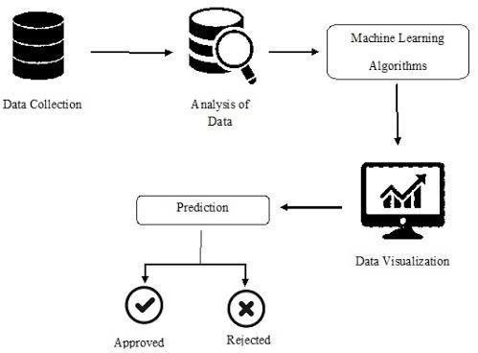

**4.2 ARCHITECTURE DIAGRAM:**

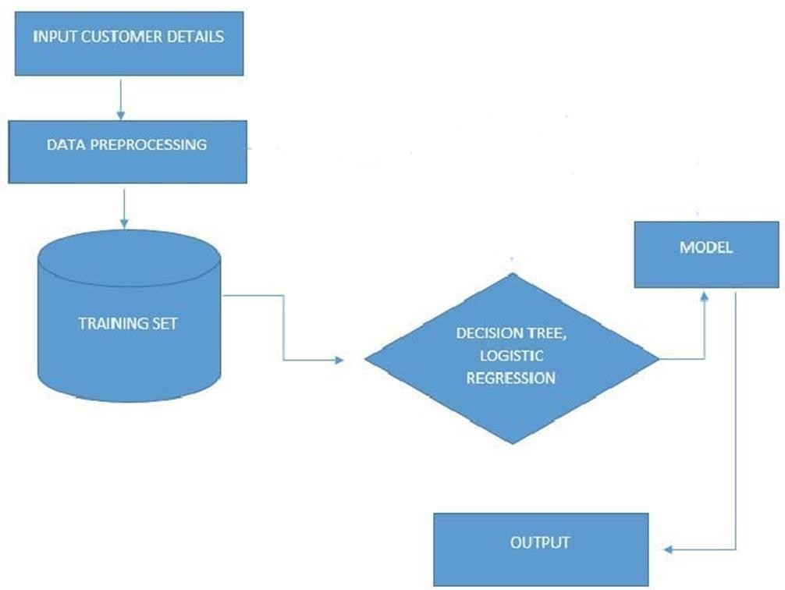

**4.3 UML DIAGRAMS:**

**USE CASE DIAGRAM**

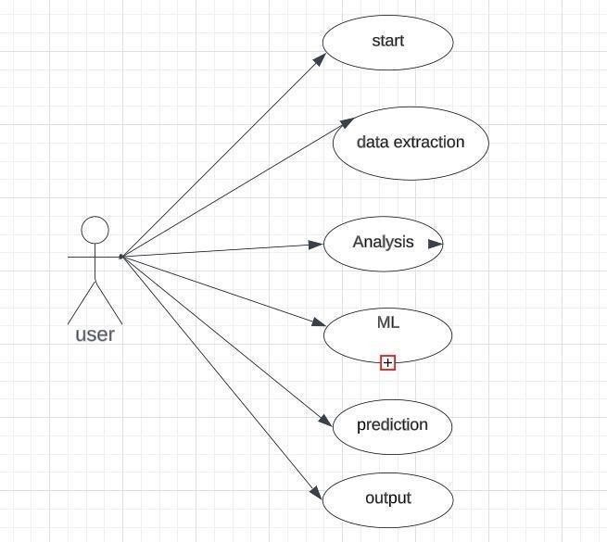

**SEQUENTIAL DIAGRAM:**

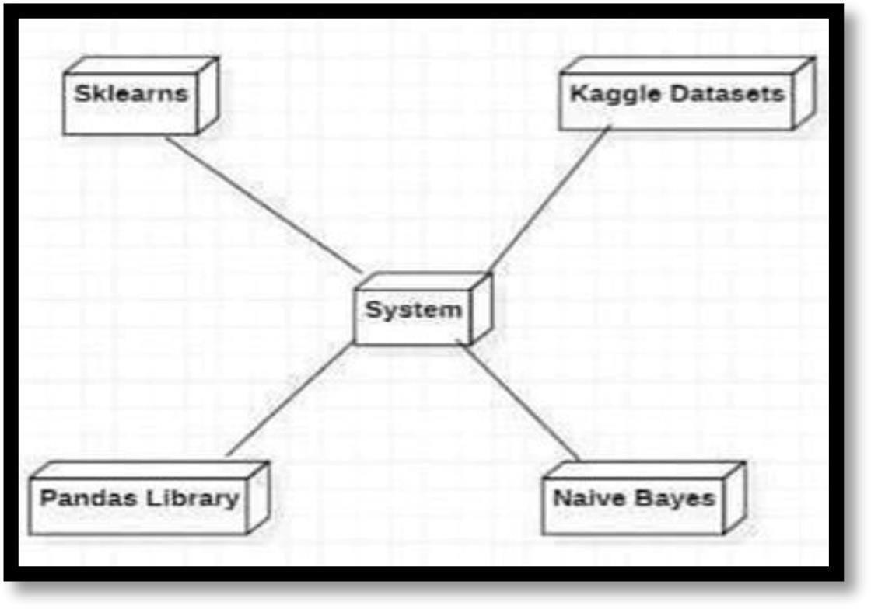

#### CHAPTER 5 SOFTWARE DEVELOPMENT LIFE CYCLE

**5.1 PHASES OF SDLC**

**Requirement Gathering**: This phase involves understanding and documenting the needs and expectations of the software to be developed. It includes gathering information from stakeholders andusers.

**Planning**: Once requirements are gathered, a detailed project plan iscreated. This involves defining scope, resources, timelines, and strategies for the development process.

**Design**: In this phase, the architecture of the software is planned. Itincludes creating system design, database design, and defining the overall structure of the software.

**Implementation (Coding):** The actual development of the softwaretakes place in this phase. Developers write code based on the designspecifications.

**Testing:** After coding, the software undergoes various testing phases -unit testing, integration testing, system testing, and user acceptance testing - to ensure it meets the specified requirements and functions correctly.

**Deployment:** Once the software passes all testing phases, it's deployedto the production environment for users to access and utilize.

**Maintenance:** Post-deployment, the software requires regular maintenance and updates to fix bugs, add new features, or adapt tochanges in the environment.

**LIFE CYCLE :-**

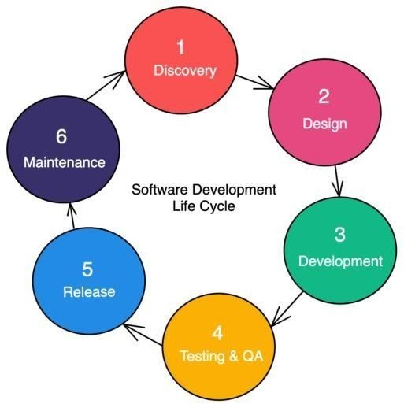

#### CHAPTER 6 IMPLEMENTATION

**6.1 SAMPLE CODE:**

These are simplified examples to give you an idea of how each modulemight be implemented. Depending on specific requirements and the libraries we choose, may need to adjust these code snippets.

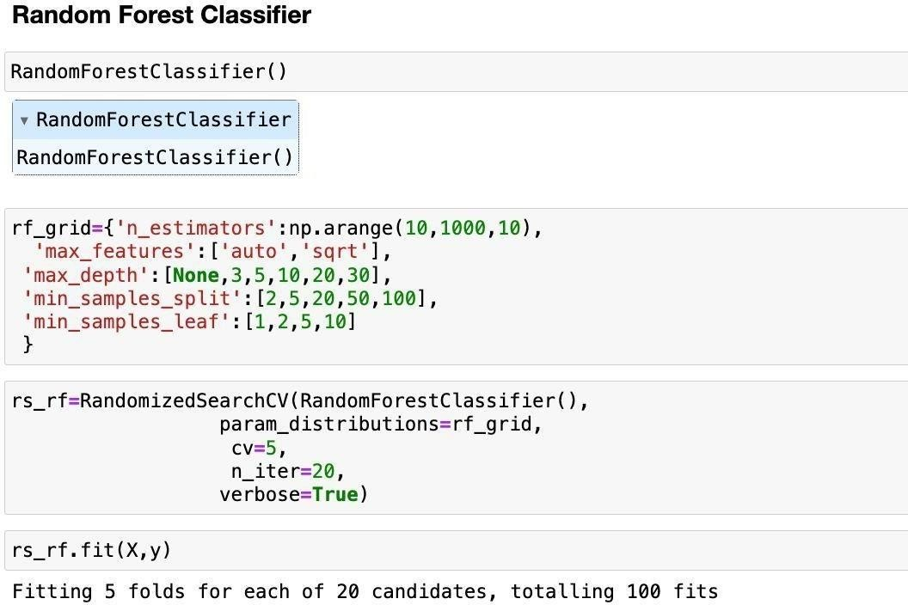

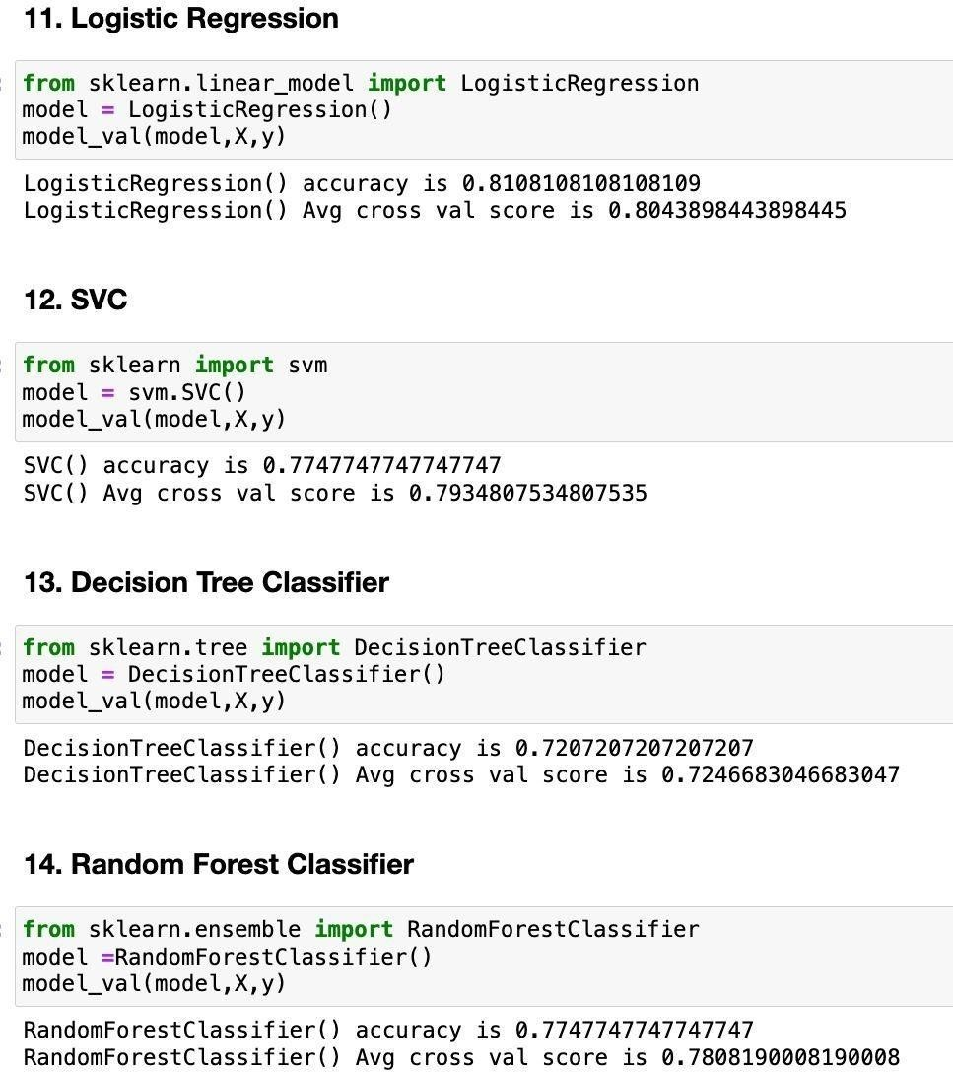

#### CHAPTER 7 TESTING

**7.1 INTRODUCTION:**

Historically, lending risk prediction has used statistical methods, including Linear Discriminant Analysis and Logistic Regression. However, with large credit datasets, ML-driven risk estimation algorithms like k-Nearest Neighbor, Random Forest, and Support Vector Machines are better at capturing complex relationships. Moreover, deep learning methods have gained a particular advantage inmodeling non-linear relationships between risk and risk factors for large- scale lending risk and loan prediction datasets.

Novel frameworks like DEAL (Deep Ensemble Algorithm), or improvements over existing models of Recurrent Neural Networks(RNN) or Boosted Decision Tree or Autoencoders, give satisfactory accuracy over large datasets and generate features with domain expertise.

However, more work is available on machine learning models than deeplearning architectures since the latter's performances are often specific to the dataset they were designed and tested on. In the figure shown below, a recent paper compares the performance of various machine learning algorithms on the German credit risk dataset

**CHAPTER 8**

**OUTPUT SCREEN**

**SCREENSHOT:**

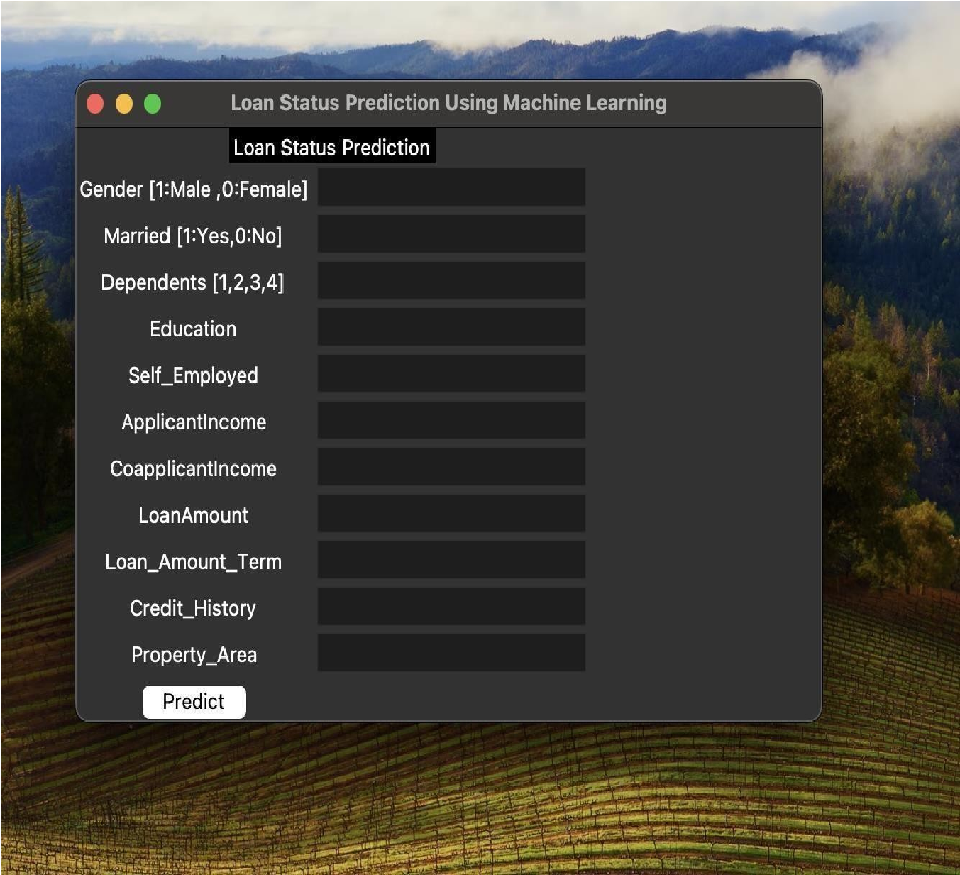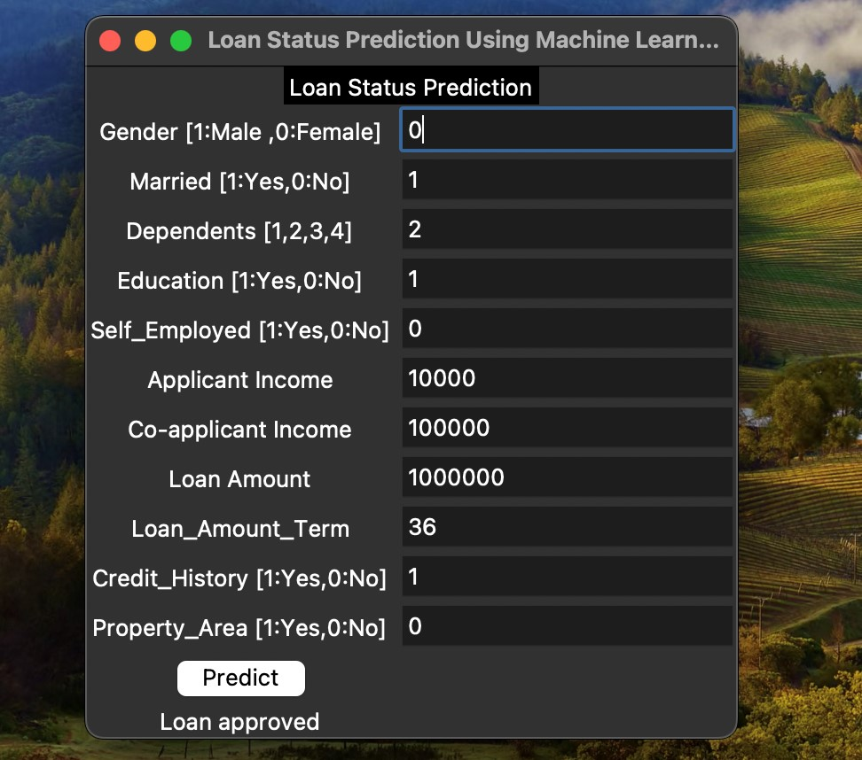

**CHAPTER 9**

#### CONCLUSION AND FUTURE SCOPE

**CONCLUSION**

In conclusion, the Loan Status Prediction System demonstrates a comprehensive approach to predicting loan approval using machine learning. Through modularization, the code is organized into distinct and purposeful modules, from data loading and preprocessing to model training, hyperparameter tuning, and a user-friendly GUI.

The Random Forest model, optimized through hyperparameter tuning, is employed for accurate predictions.

The application not only provides a robust backend for machine learning tasks but also offers a convenient GUI for users to input data and receive instant loan approval predictions.

This modular and well-structured system facilitates maintainability, scalability, and ease of integration into diverse applications.

Crucially, the pursuit of ethical AI and bias mitigation will be paramount to ensure that machine learning models contribute to fair and responsible lending practices. Future projects will likely focus on fine-tuning algorithms to avoid discrimination, adhering to ethical guidelines, and embracing global collaboration to establish standardized practices.

The incorporation of blockchain technology into the loan approval process stands out as a potential game-changer, offering enhanced security, transparency, and efficiency. Additionally, the development of user-friendly interfaces and decision support systems aims to empower financial institutions with actionable insights, seamlessly integrating predictive analytics into their operational workflows.

**FUTURE SCOPE**

The Loan Approval Prediction System using machine learning lays thefoundation for a dynamic and evolving financial decision-making process.

Looking ahead, there are several avenues for future enhancement and expansion that can contribute to the system's continued effectiveness and relevance.

Firstly, the incorporation of additional features into the machine learning model can enhance its predictive capabilities.

Techniques like neural networks or gradient boosting may uncover complex patterns within the data that traditional models might overlook.

Regular updates to the model based on new data and retraining schedules can ensure that the system remains robust and aligned with real-world scenarios.

As the importance of model interpretability and transparency continues to grow, future endeavors can focus on developing more explainable AI models. Integrating methods for interpreting complex machine learning models will not only enhance trust in predictions but also aid in meeting regulatory requirements and ethical considerations.

Future research can delve deeper into refining machine learning models, exploring advanced optimization techniques, and integrating cutting-edge algorithms. This includes the application of neural networks, deep learning architectures, and ensemble methods to further boost the accuracy and robustness of loan approval predictions.

Expanding the scope of features to include alternative data sources, such as social media activity, online behavior, or unconventional financial data, can contribute to a more comprehensive understanding of an individual's creditworthiness. Exploring and integrating non-traditional data can lead to more accurate predictions, especially for individuals with limited credit histories.

#### CHAPTER 10

**REFERENCES AND BOOKS**

1."Hands-On Machine Learning with Scikit-Learn, Keras, and TensorFlow" by Aurélien Géron

- This book provides a practical and hands-on approach to machine learning using popular Python libraries, making it a great resource for understanding the implementation of machine learning algorithms.

2. "Python for Data Analysis" by Wes McKinney

* This book focuses on data analysis using Python, which is an essential skill for working with datasets in machine learning projects.

3."Feature Engineering for Machine Learning: Principles andTechniques for Data Scientists" by Alice Zheng and Amanda Casari

* Feature engineering is a crucial aspect of building effective predictive models. This book provides insights into techniques fortransforming and selecting features in your dataset.

4. "Interpretable Machine Learning" by Christoph Molnar

* Understanding and interpreting machine learning models is essential, especially in finance. This book explores techniques to makemachine learning models more interpretable and understandable.

5."Credit Risk Analytics: Measurement Techniques, Applications, andExamples in SAS" by Bart Baesens, Daniel Roesch, and Harald Scheule

* This book specifically focuses on credit risk analytics, which is highly relevant to loan approval prediction. It covers measurement techniques and practical applications using SAS.

5."Credit Risk Analytics: Measurement Techniques, Applications, andExamples in SAS" by

Bart Baesens, Daniel Roesch, and Harald Scheule

* This book specifically focuses on credit risk analytics, which is highly relevant to loan approval prediction. It covers measurement techniques and practical applications using SAS.

6."Financial Analytics with R: Building a Laptop Laboratory for DataScience" by Mark J. Bennett and Dirk L. Hugen

* This book provides insights into financial analytics using the R programming language, covering topics relevant to predicting loan approvals.

7. "Machine Learning Yearning" by Andrew Ng

- Written by one of the leading figures in machine learning, this bookprovides practical advice and best practices for designing and deployingmachine learning systems, which can be valuable in real-world applications like loan approval prediction.